**Part 1 – Membership Dues Sheet**

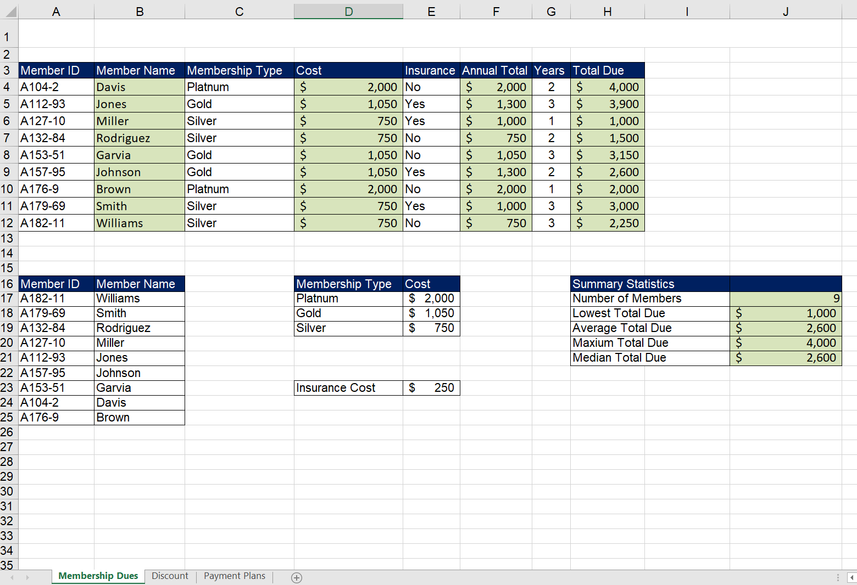

**Part 2 – Discount Sheet**

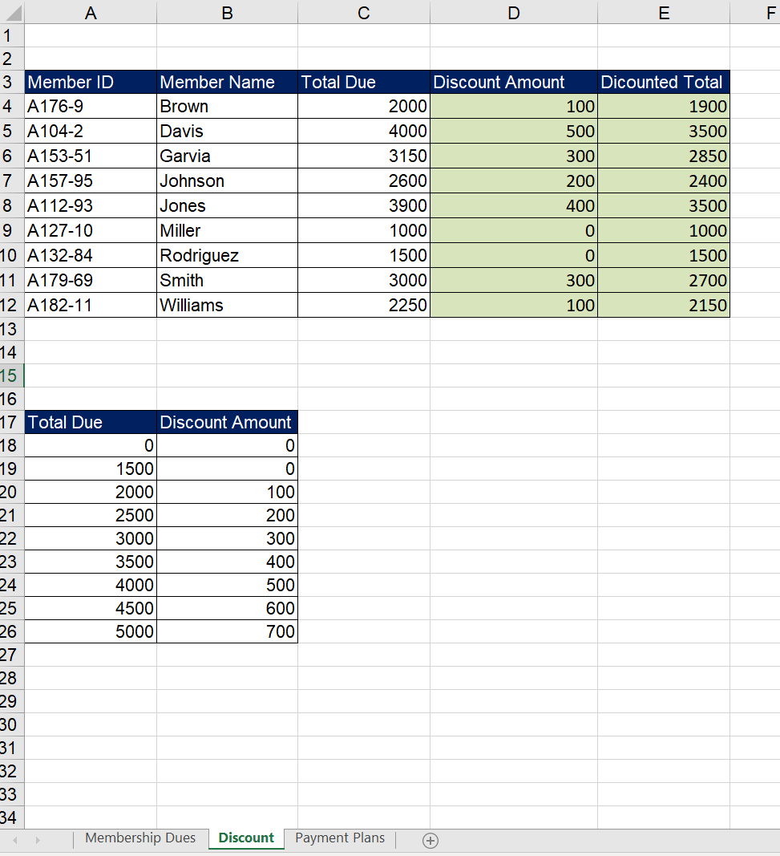

**Part 3 – Payment Plans Sheet**

